Speed up the process of data lookup. Instead of getting data from the actual data store which may be another remote system or db server

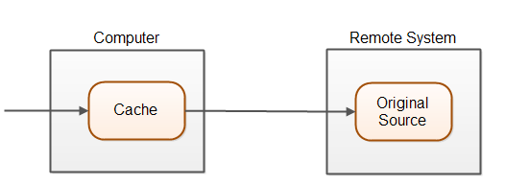

Data storage close to the data entity needing it. Accessing cache is faster than the accessing the data from the store.

It can be on the memory or the disk.

Memory cached is faster than the disk cache.

Chace lost on restart of the system.

Modern web application can happen at 3places:

1. Browser

2. Web Server

3. Data base

